Sketchfab VR Link by C12

The Whole City with the stadium and the roof

<https://skfb.ly/6xvRN>

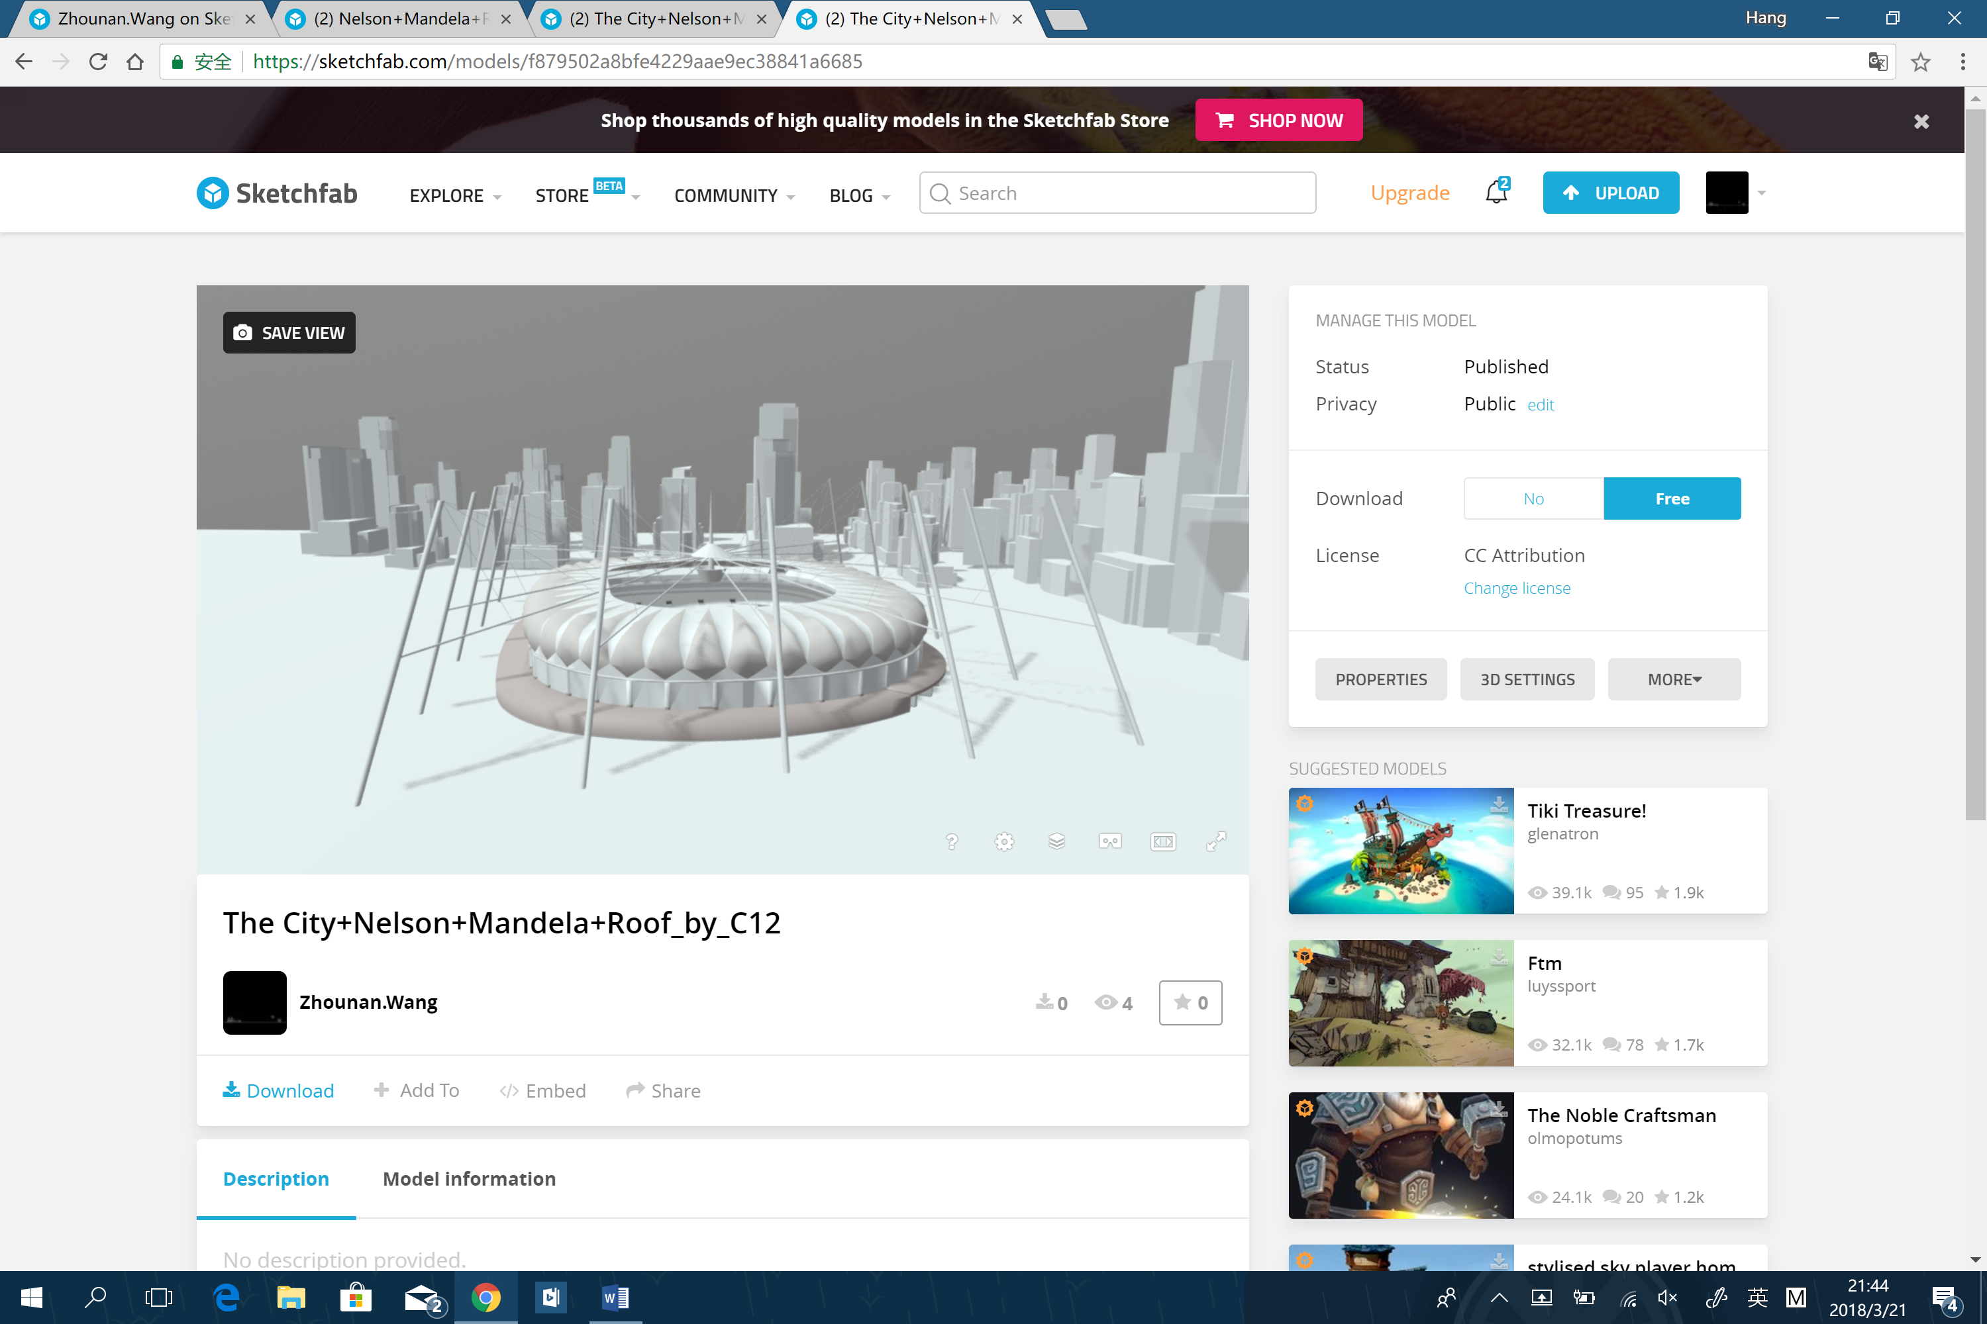

The stadium and the roof detail

<https://skfb.ly/6xv8x>

